Software Requirements Specification

**For**

Online Leave Management System

# Prepared By

B.Uday Kumar

PACE IT’S

Online Leave Management System

Table Of Content

**1. Abstract**

1.1) Introduction

1.2) Scope

1.3) Technologies to be used

1.4) Overview

**2. Overall Description**

2.1) Product Perspective

2.2) Product Functions

**3. Functional Requirements**

**4. Non-Functional Requirements**

4.1) Class Diagram

4.2) System Flow Chart

4.3) Entity-Relationship Diagram

**5. Specific Requirements**

**1. Abstract**

This project is aimed at developing an online leave management system that is of importance to an organization. The Leave Management System (LMS) is an Intranet based application that can be accessed throughout the organization or a specified group/Dept. This system can be used to automate the workflow of leave applications and their approvals. The periodic crediting of leave is also automated. There are features like email notifications, cancellation of leave, automatic approval of leave, report generators etc. in this system.

* 1. **Introduction**

This Software Requirements Specification provides a complete description of all the functions and specifications of the Online Leave Management System. The expected audience of this document is the business development Manager , Service Delivery and Support Manager, including members of the organization who will use this system.

Anyone who has applied for leave will know the frustration of form-filling – and waiting as the hard copy travels up and down the approval hierarchy. This brilliant electronic leave management software with its powerful features, cuts out the physical movements and enables HR to have a bird’s eye view of the leave situation in the organization or college, and make decisive, on-the-spot approval decisions.

**There are many advantages of utilizing a web based leave tracking system:**

* Eliminates paper based leave application forms.
* Leave applications can be submitted online
* Leave applications can be approved online
* Both the leave applicant as well as the approver can view the remaining leave days as well as historical leave applications

**Employees can easily:**

* Apply for leaves online where upon submission; the supervisor will be notified via email that there is a leave to approve.
* View the number of remaining leave days.
* View historical leave taken.
  1. **Scope**

The online Leave Management System is designed to run on the organization’s server and to allow employees to apply for their leave balance, revoke leave application, and cancel leave. Consequently, the line manager should be able to review the contents of the leave application and approve or reject the applications.

* 1. **Technologies to be used**
* Canvas Applications
* Model-Driven Applications
* Common Data services
* Power Apps
* Power BI
* Power Automate

**1.4) Overview**

* SRS includes two sections overall description and specific. The end user should have a basic knowledge of English and computer usage.
* Overall description will describe major role of the system components and interconnections.
* Specific requirements will describe roles & functions of the actors.

1. **Overall Description**

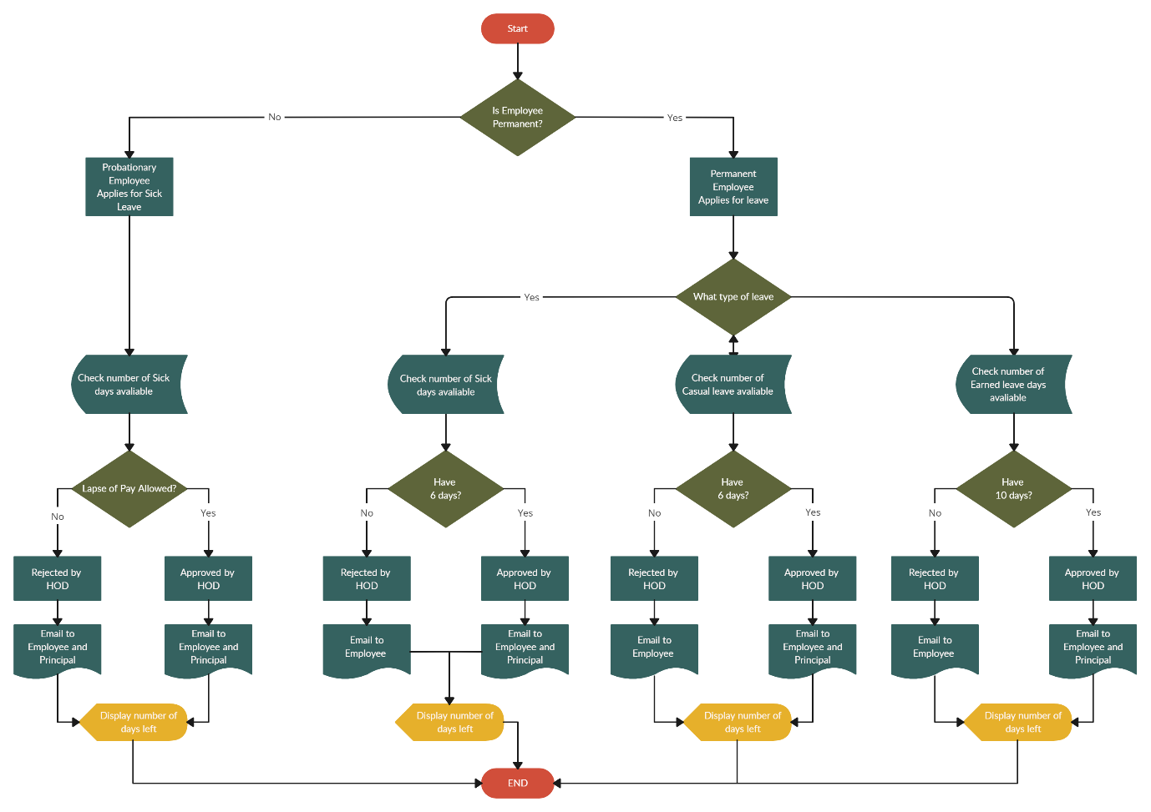

**2.1) Product Perspective**

**Leave Management Software** facilitates the effective and smooth management of personnel leave. The Organization can always be up to date with their leave management. With comprehensive reporting and Web based applications. This system facilitates the total leave process, from completing leave applications by employees, leave application approval by HOD & Management to setting up your specific Organization parameters such as leave types (sick leave, Annual leave, etc.).

**Administrative Settings**

* Choose the **types of leave** allowed - Sick, Annual, Family Responsibility, Maternity, Study, Unpaid, etc.
* Choose the **number of days** allowed for each of the types. A **default** is set for all the employees, but admin can also modi**fy** it per employee.
* Leave can be **allocated** annually or monthly depending on your company policies.
* Choose the persons to be **notified** when leave requests are received.

**Employees**

* An leave **summary** shows the employee, how many leaves are available, how many they have taken and the status of their leave applications.
* Easily **apply** for leave choosing the required leave type and amount of hours or days.
* Employees can upload **supporting documentation**, such as university documents or sick notes when they apply for leave.
* The **Leave Management Software** is completely **secure**, thus employees can't view each other's leave statuses.

**Leave processing and reporting**

* A **notification** is received by relevant manager/s when a leave application is submitted by an employee.
* The relevant manager can then log in and choose to **approve or reject an application**. Reasons can also be provided. The employee will be notified once the leave application is approved or rejected.
* A **summary** can be selected whereby management, HR or the persons tasked with managing the employees leave can **search** via an employee and leave year, to get a summary of the employees current leave applications as well as his outstanding leave days per category such as sick leave, maternity leave, yearly leave etc.
* We make **reports** on Leave Management System. Simply select data to include in your reports such as department, employee name, leave year, leave status, dates and the output format for example **HTML, PDF,Excel, XML and DOC etc....**

**2.2) Product Functions**

* On-line application for leave without the need for paperwork.
* Email notifications to approving officer and applicants.
* Applicant and Approving Officer can see complete leave records and approval history respectively.
* Leave records are updated automatically once applications are approved.
* Leave records may be printed out or generated into reports.
* Leave records may be exported to any back-end system.
* Advanced Features such as block leave, document tracking, leave adjustment.
* Leave calendar provides a bird's eye view of who's on leave.
* All leave policies are configurable (i.e no software customization required).

1. **Functional Requirements**

Functional requirements outline what the system must do. I.e. what services the system present to the user? Following is a list of functionalities of the system. There are registered people in the system. Some are leave approvers. An approver can also be a leave requestor. In an organization, the hierarchy could be Engineers/Managers/Business managers/managing Directors etc.

* 1. An employee should be able to:
* Login to the system through the first page of the application.
* Change the password after logging into the system.
* See his/her eligibility details (like how many days of leave he/she is eligible foretc.)
* Query the leave balance
* See his/her leave history since the time he/she joined the company/college
* Apply for leave, specifying the from and to dates, reason for taking leave, address for communication while on leave and his/her superior’s email id.
* See his/her current leave applications and the leave applications that are submitted to him/her for approval or cancellation.
* Approve/reject the leave applications that are submitted to him/her.
* Withdraw his/her leave application (which has not been approved yet).
* Cancel his/her leave (which has been already approved). This will need to be approved by his/her Superior.
  1. As soon as a leave application/cancellation request/withdrawal/approval/rejection/password-change is made by the person, an automatic email should be sent to the person and his superior giving details about the action.
  2. The no. of days of leave (as per the assumed leave policy) should be automatically credited to everybody and a notification regarding the same be sent to them automatically.
  3. A summary report of the leave details of his/her sub-ordinates should be sent to every manager periodically
  4. A calendar giving the public holidays of the organization/college should be available on the system

1. **Non-Functional Requirements**

4.1 Class Diagram:

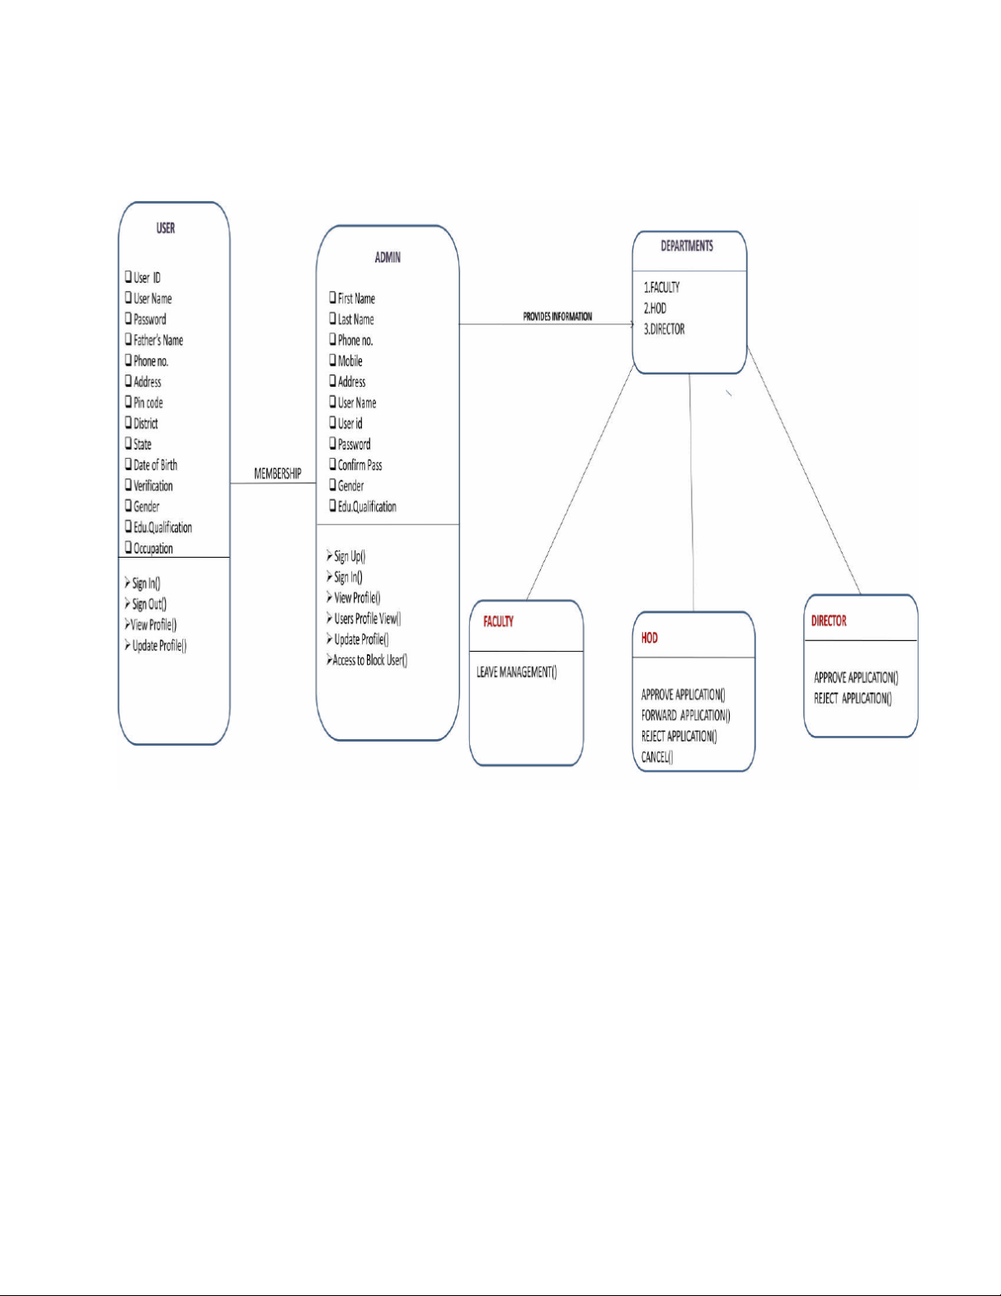

**4.2 System Flow Chart:**

**START**

STATUS CHANGED TO

APPROVED

STATUS CHANGED TO

REJECTED

**SEND MAIL**

APROVE/

REJECT

APPLY LEAVE

**END**

FETCH RECORDS

(leave balance,calender etc..)

**LOGIN**

**Login**

**Accept/reject**

REJECTED ACCEPTED

**4.3) Entity-Relationship Diagram**

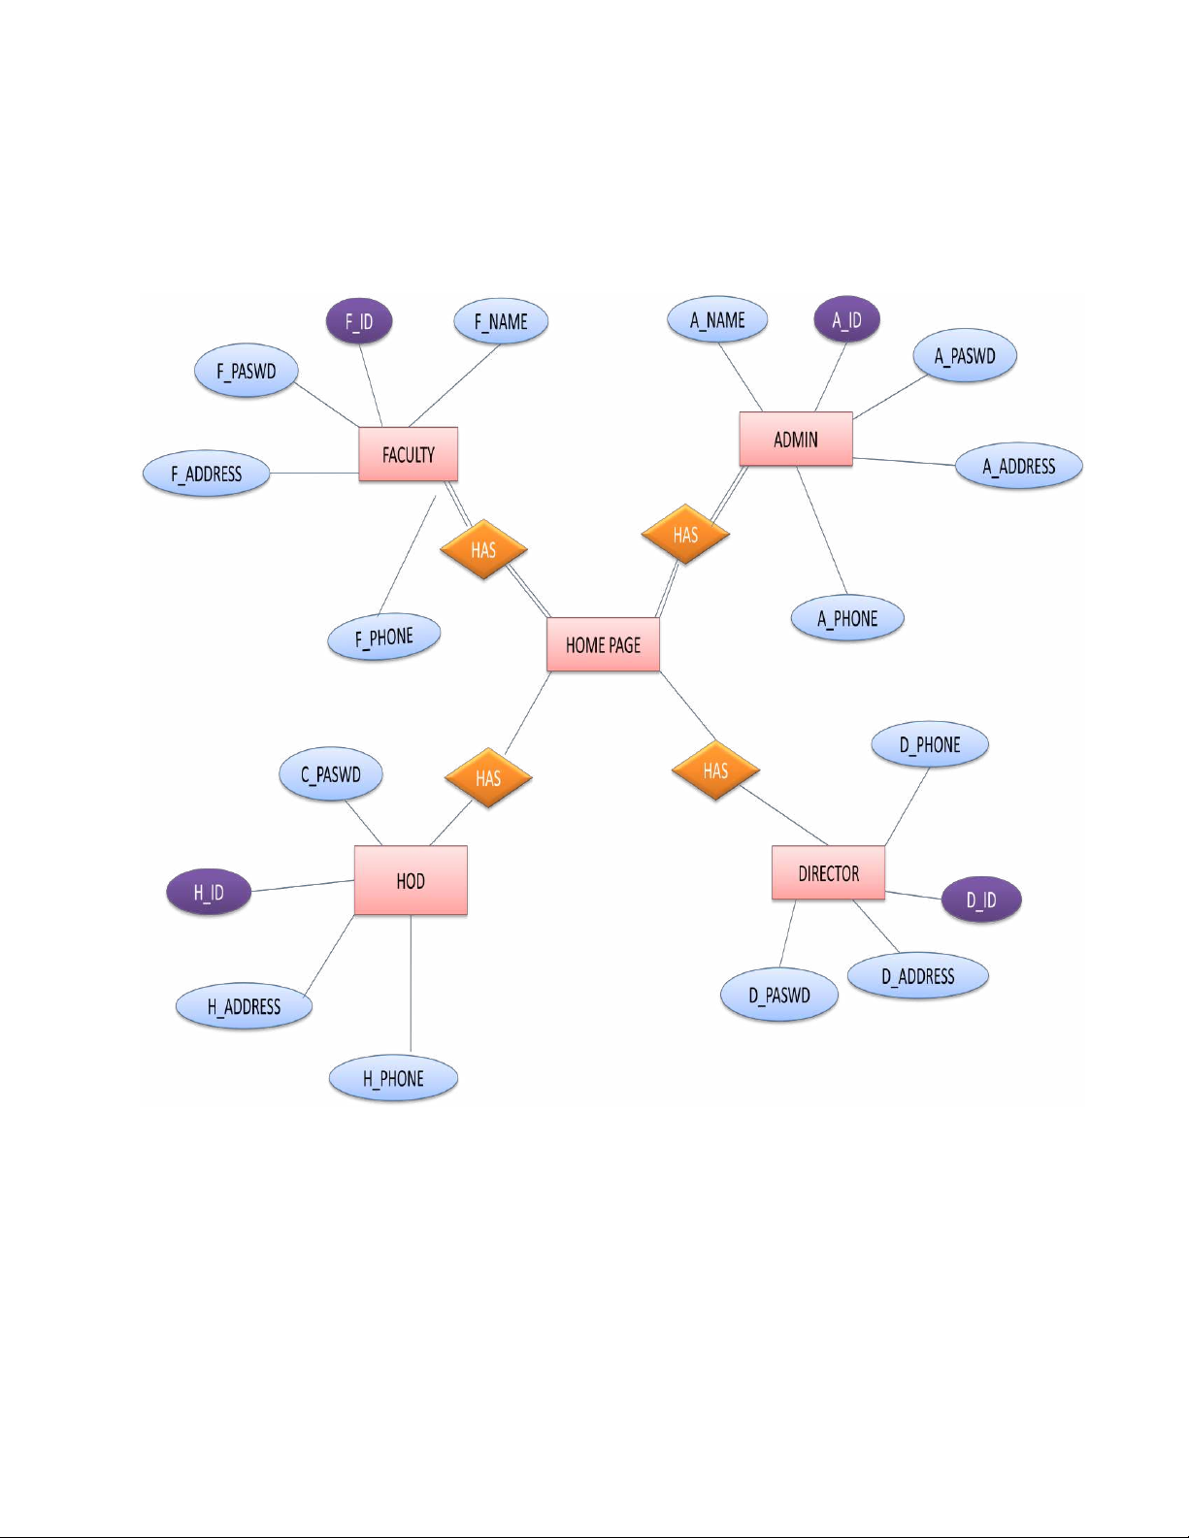

1. **Specific Requirement :**

**• END USER**

* **Sign up**

In order to apply for various information and end user must sign up by filling the form and get it approved by admin.

* **Sign in**

After getting the username and password, end users can log on to their account and can access the website.

* **Open Profile**

End user can open their profile which contains the personal details which he/she provided during sign up.

* **View Profile**

End user can view their profile which contains the personal details which he/she provided during signup.

* **Submit Application**

End user can come to the portal and can submit his/her application directly or can view other details directly.

**• ADMINISTRATOR**

* **Verify Details**

Admin authenticates all the end users by checking their username and password.

* **Provides login account**

After getting the sign up details from the end user, Admin provides the username and password to the end user that should be kept for future login and also admin checks for uniqueness.

* **Maintains system server**

Admin maintains the centralized system serverwhich controls the client computers.

* **Maintains database**

Admin maintains the entire database and he is theonly authorized person to add/remove/editemployee records.

* **Accepting new registration**

Admin can accept the new registration depending upon the details enclosed by end user.

* **Declining new registration**

He can also decline if the details enclosed are illegal or not correct.

**• Faculty**

* **Sign In**

First the User has to login to his account to start his work. He has to take care about illegal activities.

* **Submit leave**

The Faculty can submit his/her leave and can also check his status.

**• HOD**

* **Sign In**

First the HOD has to login to his account to start his work.

* **GET/Enter Details**

The HOD can view the applications submitted by faculty and can accept and forward the application to director and can reject their applications.

**• Director**

* **Sign In**

First the Director has to login to his account to start his work.

* **GET/Enter Details**

The Director can view the applications forwarded by HOD and can accept and can reject their applications.